***Gantry [2.0]***

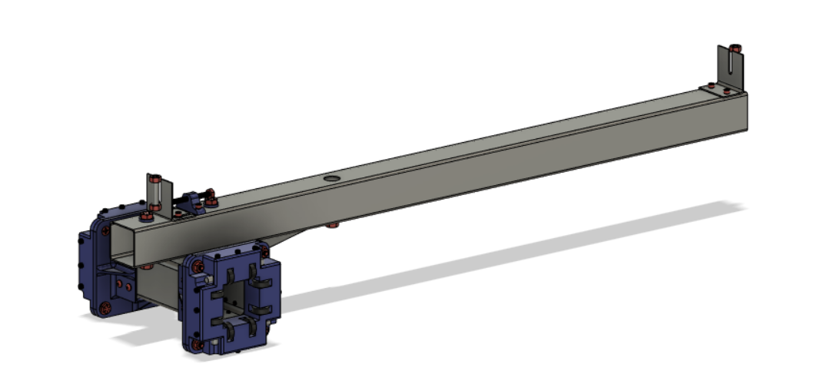

***Gantry Tube [2.1]***

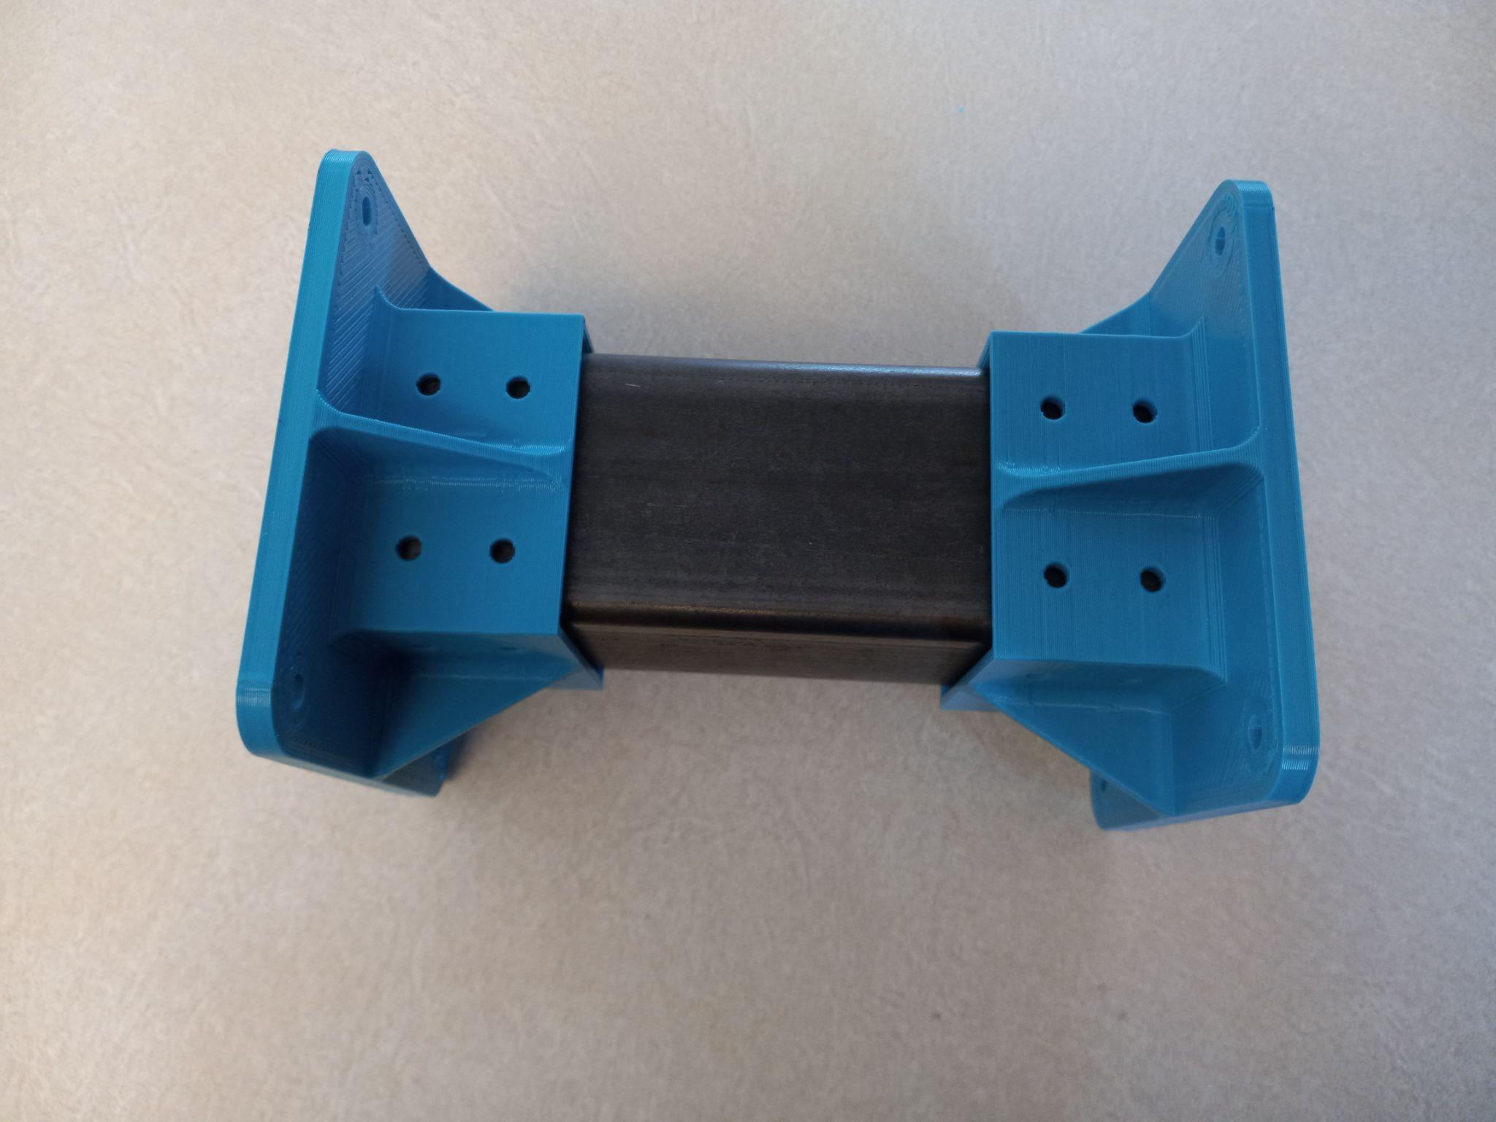

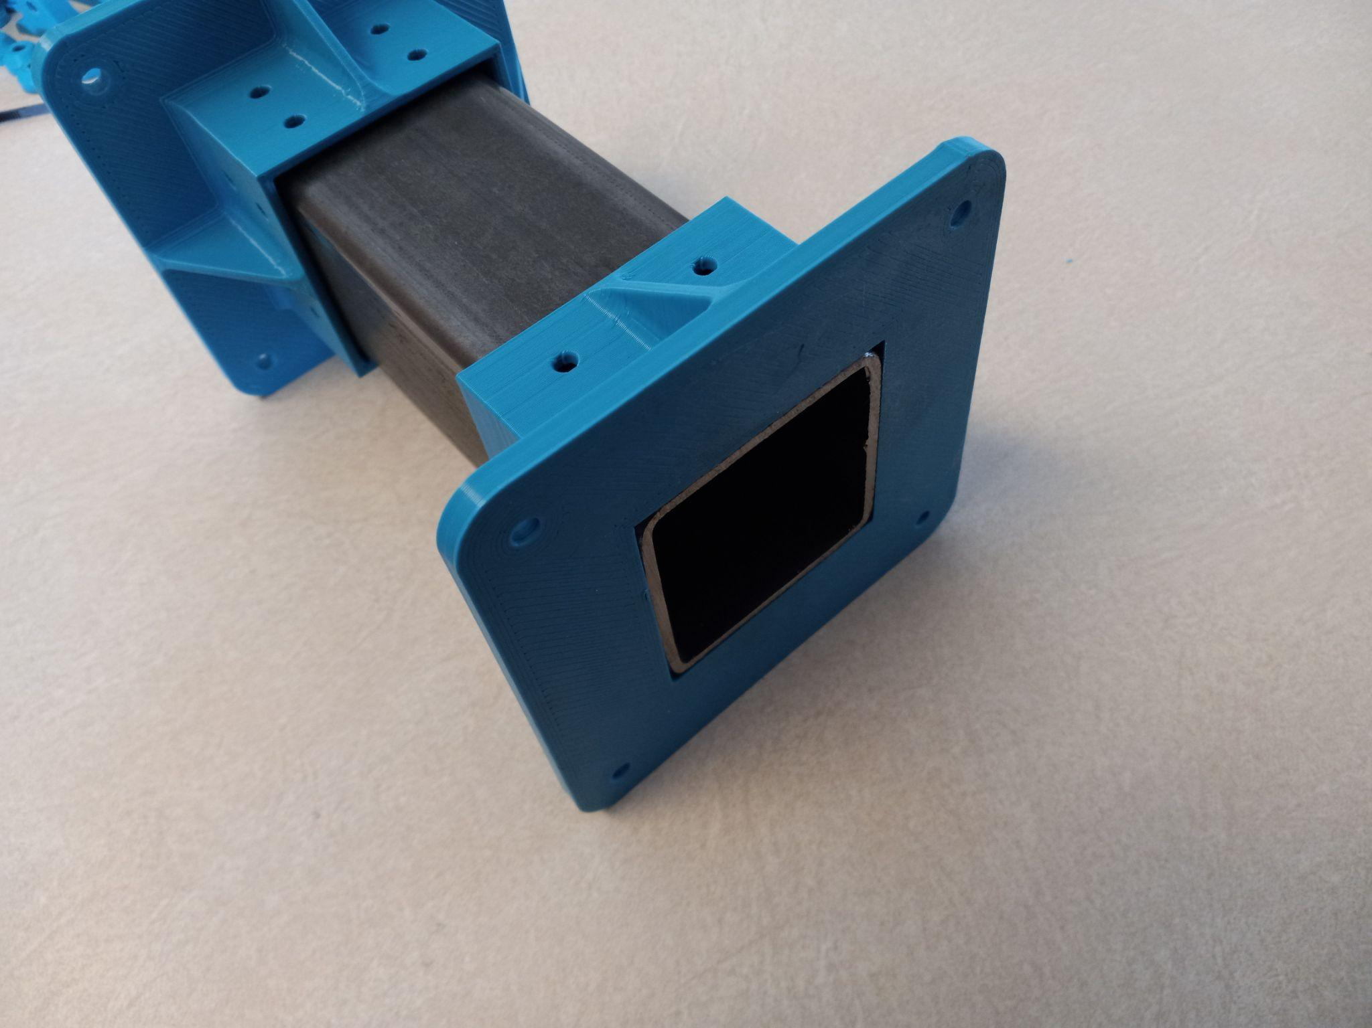

Gantry Tube is made from 2.5” - 0.120” section of tube cut 7.5” long

To get the holes properly drilled in the Gantry Tube, place the flanges on the ends and use them as guides to drill the holes in the right positions.

Drill and tap for #10-32 threads

***Center Gantry [2.2]***

**Parts Needed**

**1x Gantry Tube**

**1x Top Gantry Plate**

**1x Triangle Bracket**

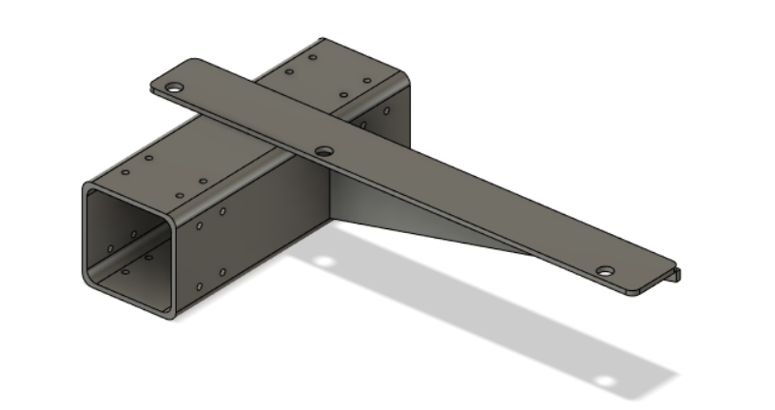

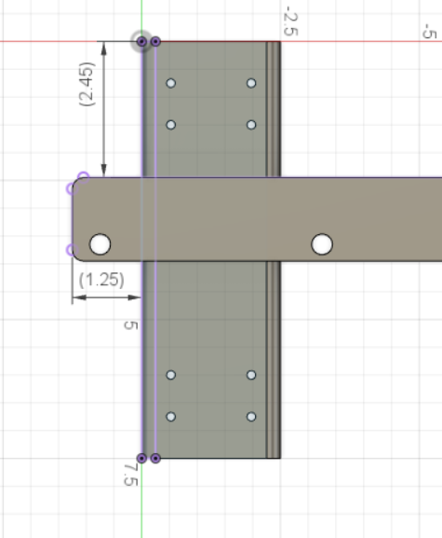

Dimensions for the Gantry Tube to Top Gantry Plate. The 3 bolt holes on the Gantry Plate should be in the center (3.75”) of the Gantry Tube.

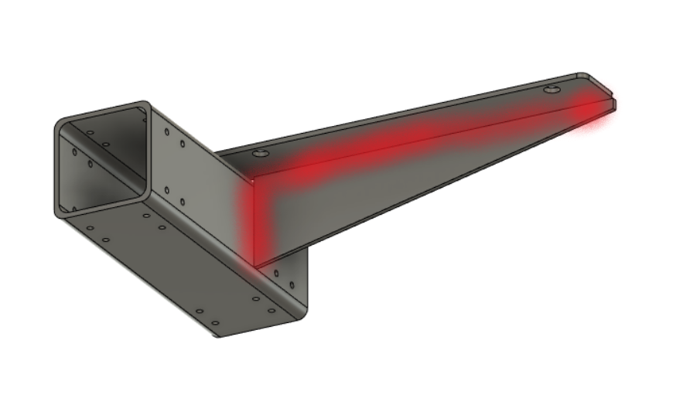

Weld the components on the red area

***Gantry Flange [2.3]***

**Parted Needed**

**1x Center Gantry**

**1x Gantry Flange (3D Printed)**

**1x Gantry Flange-Motor (3D Printed)**

**4x #10-32 - 3/8” flat head screws**

**28 #10-32 -3/8” phillips rounded head screw**

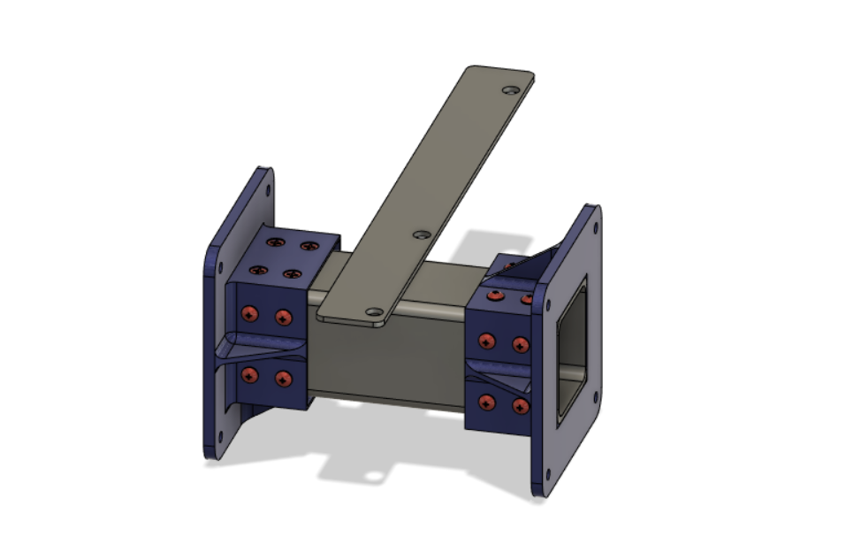

***Bearing Block Assembly [2.4]***

Make 2 of these

**Parts Needed**

**1x Bearing Block (3D Printed)**

**4x 5/16” - 3” pins**

**8x 608zz Bearings**

**8x 1/4” - 1/2” set screws**

**16x 608 Bearing Washers(3D Printed)**

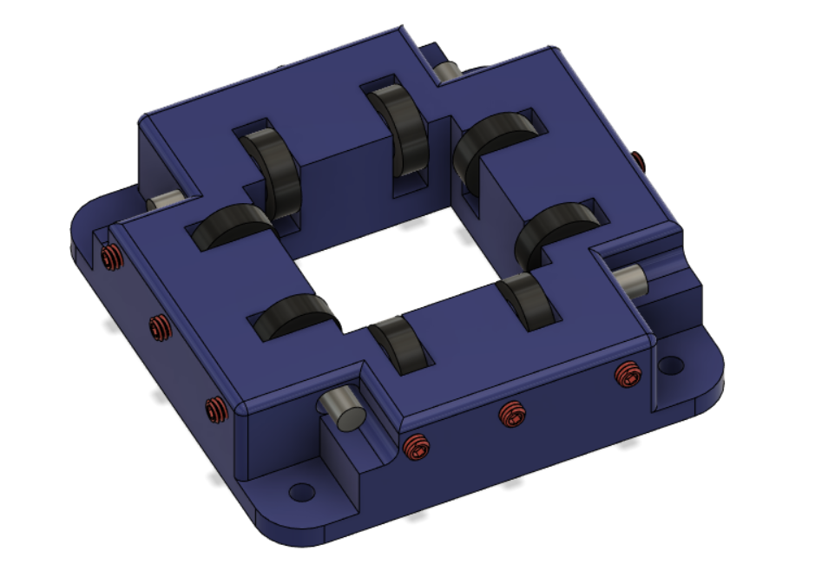

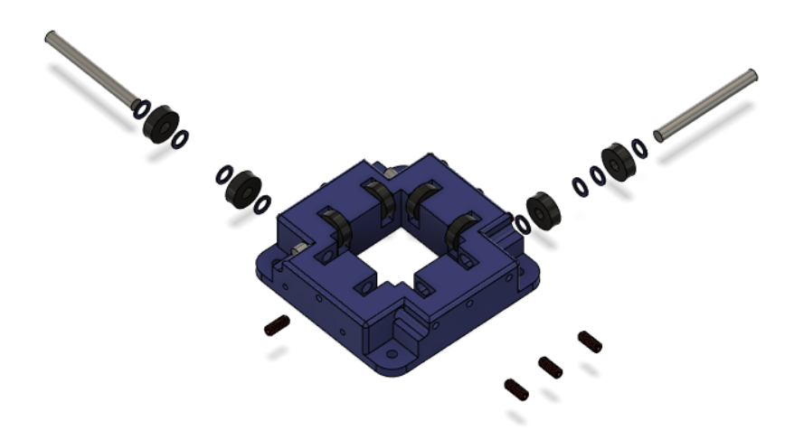

Bearing Washers go on either side of the bearing and set screws tighten up against the 5/16” shaft to set preload and alignment.

***Gantry Bearings [2.5]***

**Parts Needed**

**1x Gantry Flange**

**2x Bearing Block Assemblies**

**1x 1/4” - 1” Phillips Flat Head Screw**

**7x 1/4” - 1” Bolts**

**8x 1/4” Nuts**

**15x 1/4” Washers**

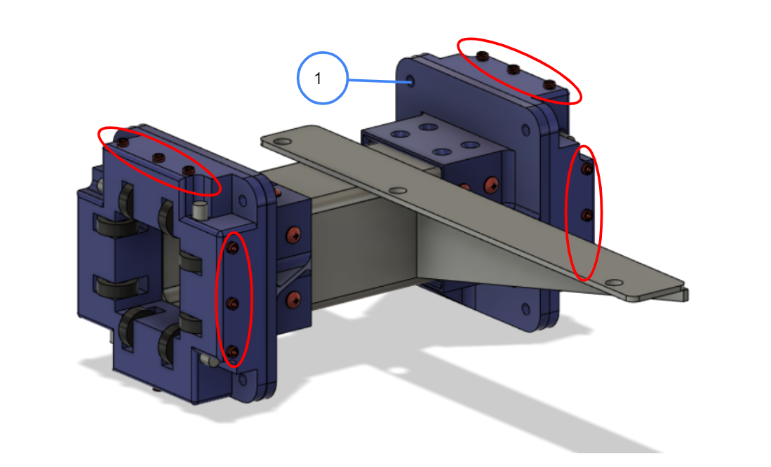

1- Drill a countersink for this hole with a ½ ” drill bit

Y-axis bearing blocks should not be attached to gantry flanges until bearings are adjusted for proper fit on tubing. The sides with 3 set screws should be facing upward and inward. Adjust the top bearings first. Tighten the center set screw until just snug. Roll bearing assembly back and forth along the tube keeping it perpendicular to the tube, loosen slightly if necessary. There should be no play. Tighten the outer 2 set screws until only slight resistance is felt. Move to the inside plane and follow the previous steps to adjust that set of bearings. Repeat the procedure with the second bearing block. We have found that it is best not to remove the bearing assembly from the tube once the bearing load is set. If you have rough spots when moving the bearings, use a large flat file and smooth out the areas on the tube where the bearings run. Attach the bearing blocks to the gantry flange mounts with eight 1/4" bolts. Do not tighten. The X-axis arm must be level to the bed before tightening. Take measurements nearest the Y-axis and furthest outward. Both must be the same. Once these are the same, tighten the 8 bolts and recheck. This must be perfect. If you can't get the dimensions equal, try drilling out the 8 holes in the bearing support mounts 1 size bigger.

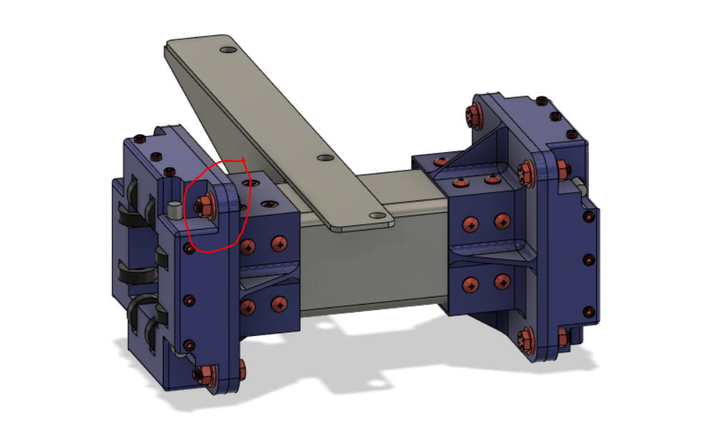

Circled is the countersunk hole with a flat head screw. This is required for stepper motor clearance.

***Gantry Tube Assembly [2.6]***

**Parts Needed**

**1x Gantry Bearings**

**1x 38” X-Axis Tube**

**1x 3/8” - 1/2” bolt**

**2x 3/8” - 2.5” bolts**

**2x Bolt Spacers (3D Printed)**

**3x 3/8” Nuts**

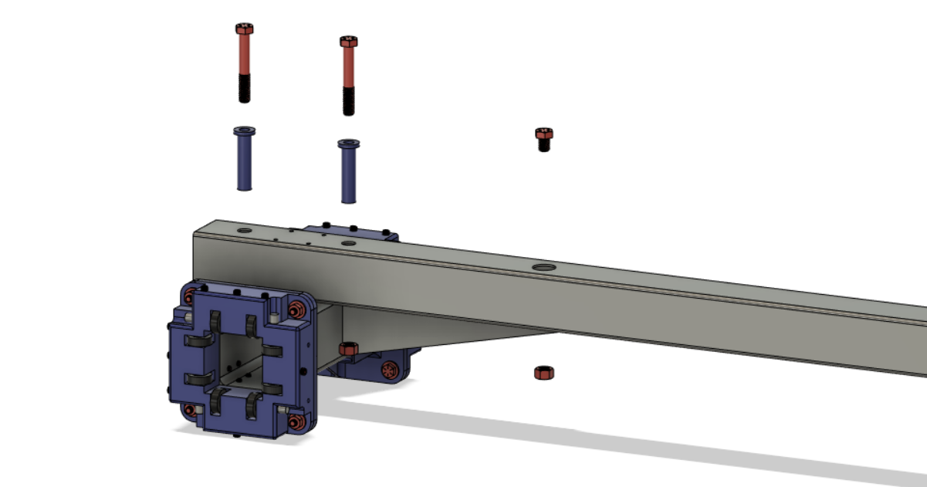

***Complete Gantry [2.7]***

**Parts Needed**

**1x Gantry Tube Assembly**

**1x Active Belt Mount**

**1x Idle Belt Mount**

**1x Belt Tensioner (3D Printed)**

**1x 1/4”- 2.5” All Thread Bolt**

**2x #10 washers**

**2x #10-32 - 5/8” Cap Screws**

**4x #10-32 - 3/8” Cap Screws**

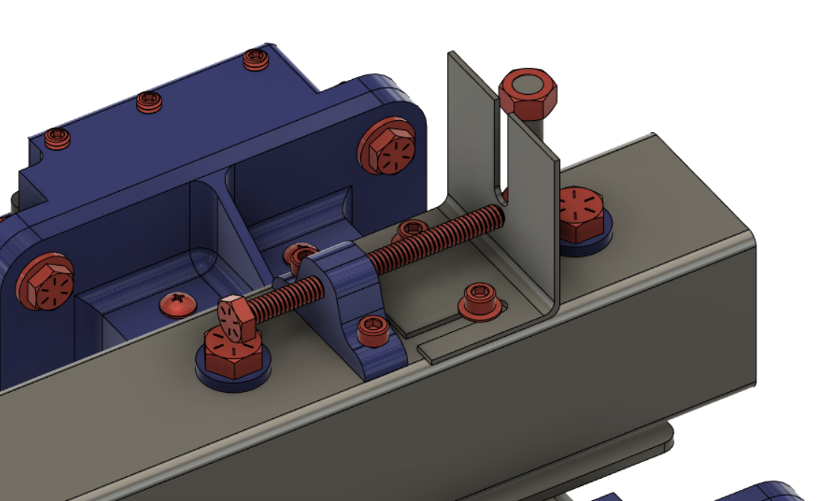

Use the long screws to secure the belt tensioner and the short screws to secure the washers

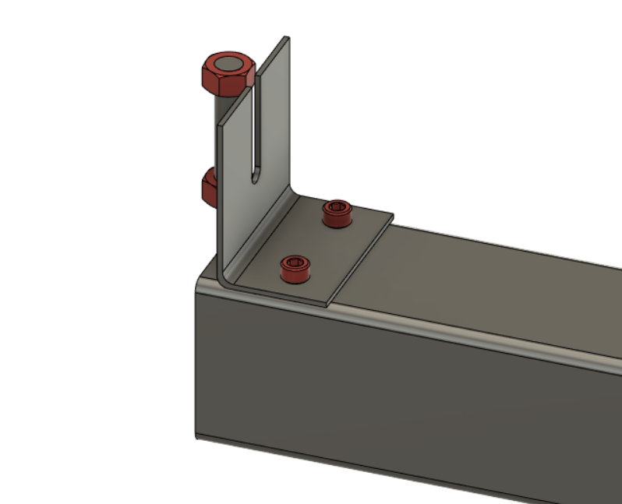

Use the remaining short screws to secure the idle belt mount at the far end of the gantry.